12.DFA SUBSTRING ab

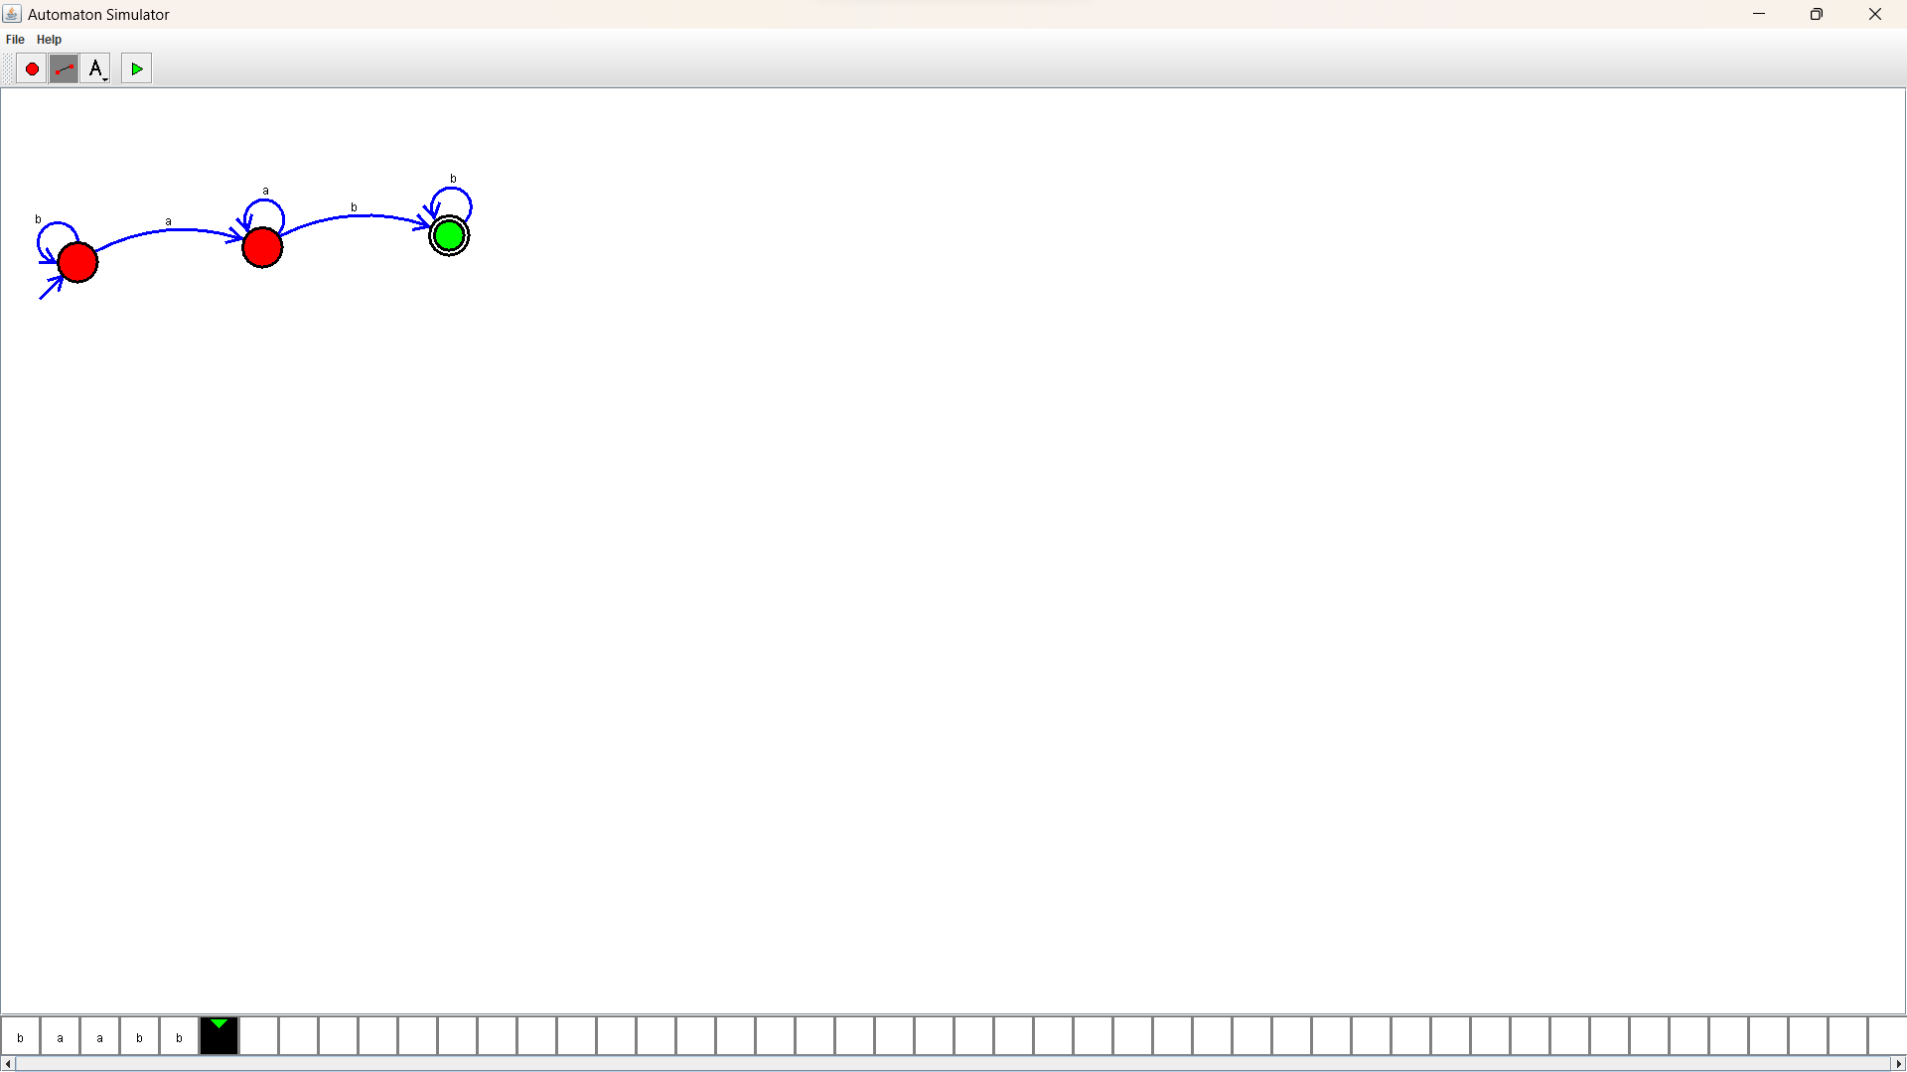Output :

Output :

